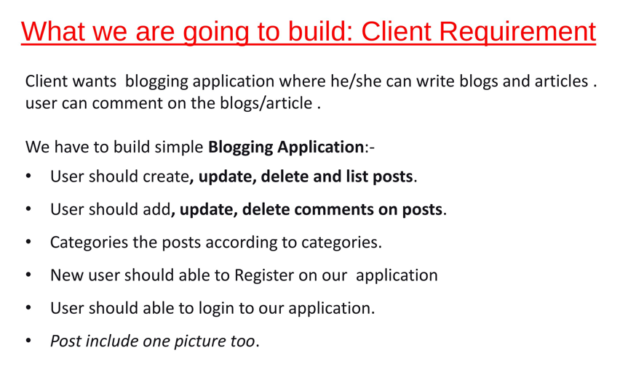

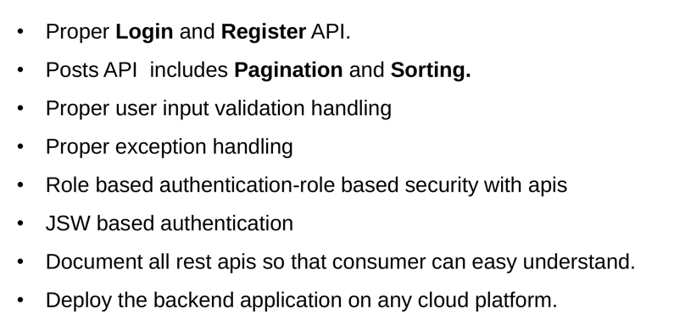

**Technology and Tools Used:**

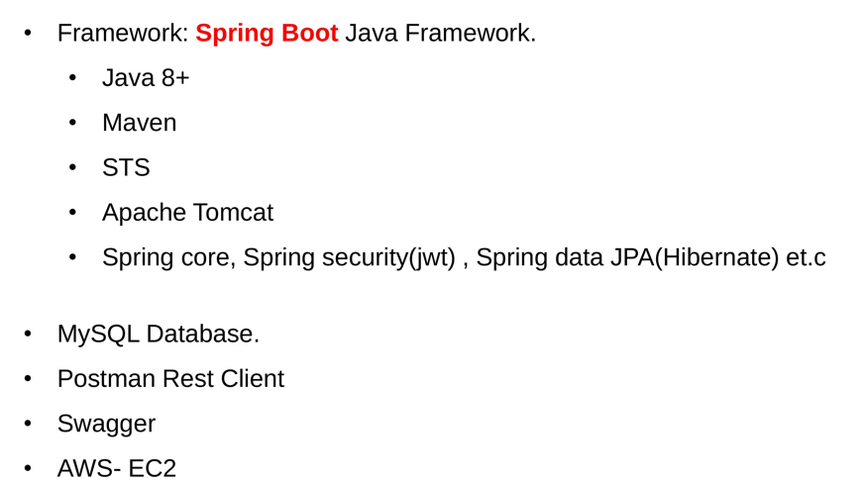

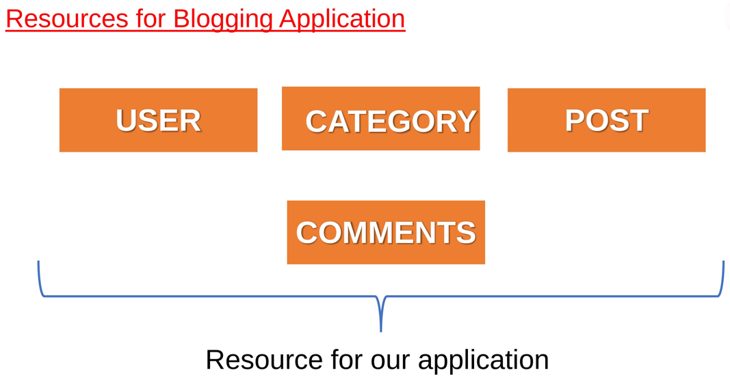

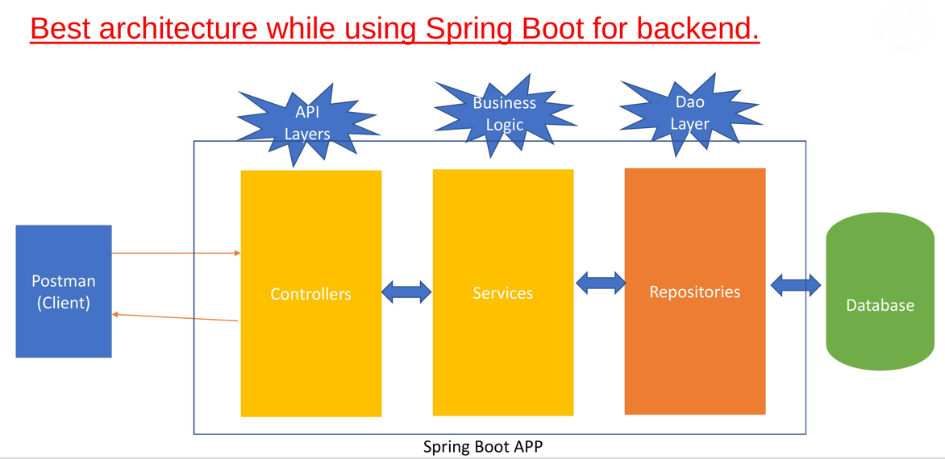

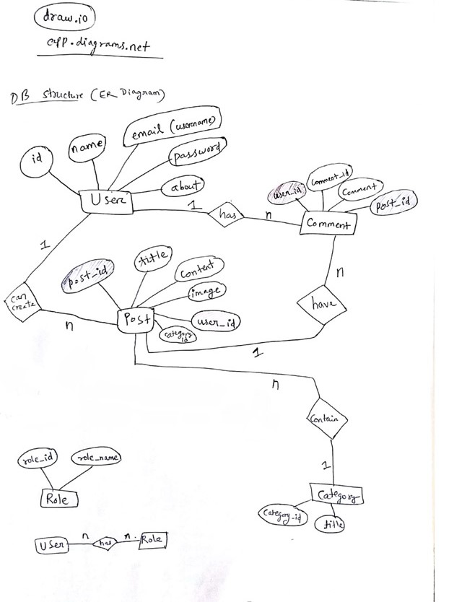

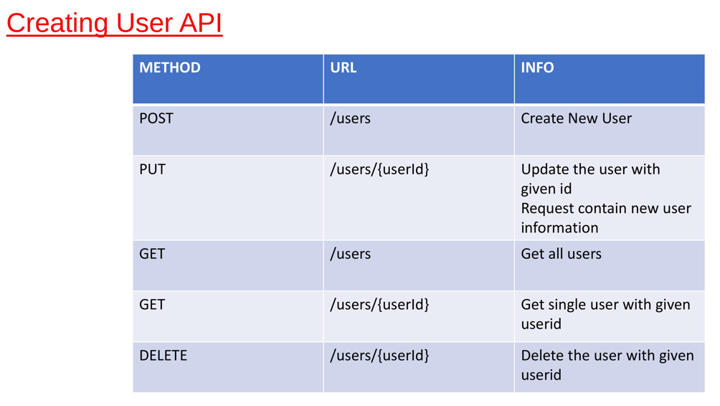

***Users Functionality:***

* Add user
* Update user
* Delete user
* Get single/multiple users

***Category Functionality:***

* Add Category
* Update category
* Delete category
* Get single/multiple category

***Post Functionality:***

* Create post
* Update post
* Delete post
* Get All post
* Get post by Id
* Get Post by categoryId
* Get posts by UserId
* Search posts by keyword

***Pagination Functionality:***

PostController: to customize the no. of posts per page we have provided pageNumber and pageSize as the request Params.

We have used a class PostResponse to provide custom Pagination effect:

It has following fields:

*List<PostDto> content;*

***int*** *pageNumber;*

***int*** *pageSize;*

***long*** *totalElements;*

***int*** *totalPages;*

***boolean*** *lastPage; (if current page is lastPage then value is true)*

**Sorting by some field and an order:**

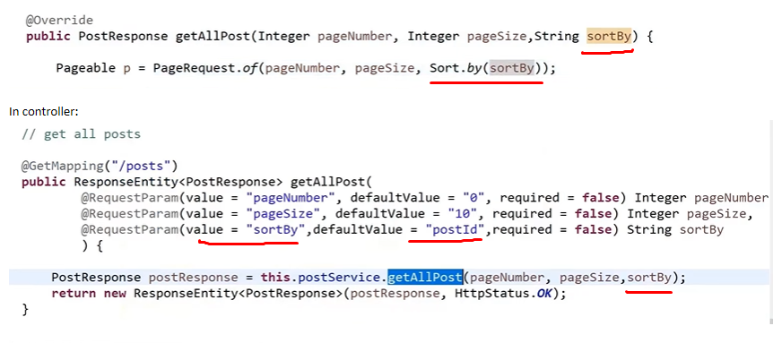

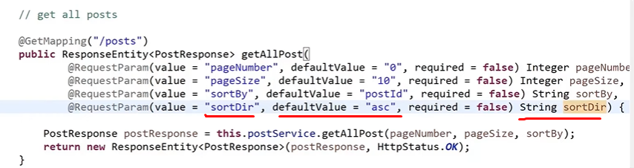

**Searching**: *User can search a post by title using a keyword*

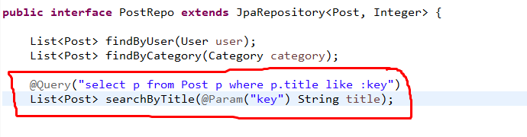

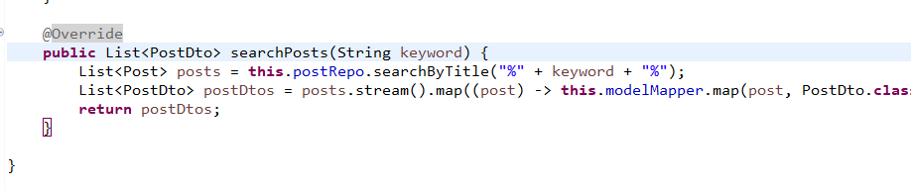

**Image uploading in Post**:

User has to create the post and then upload the image using uploadImage api

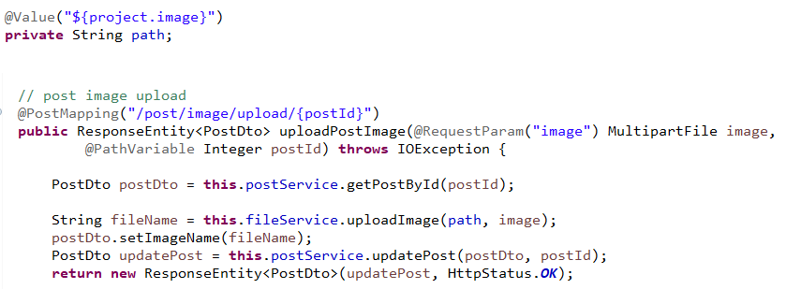

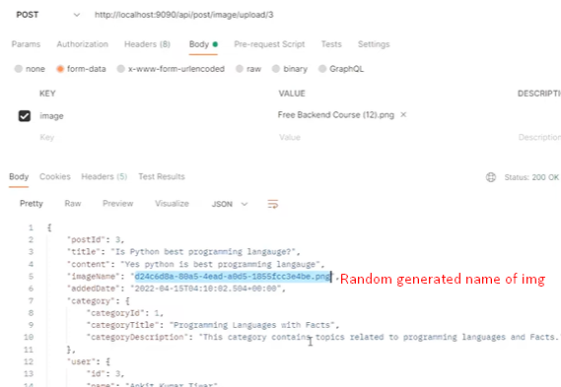

**Comment Api**

*Fields:*

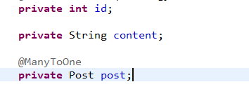

*Functions:*

* Create comment
* Delete Comment

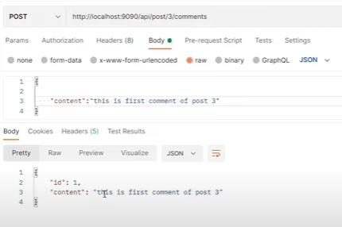

***Authentication based on Spring Security:***

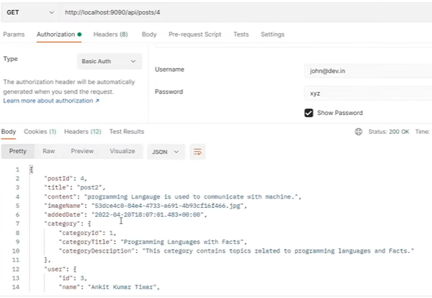

These username and password is extracted from DB and validated

Next JWT based authentication is implemented

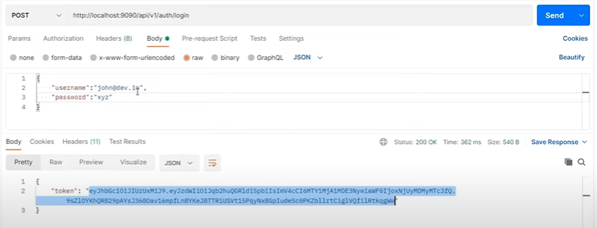

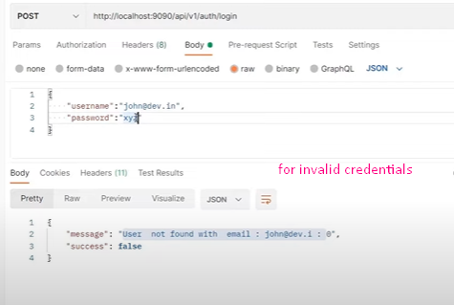

Accessing Apis using Token

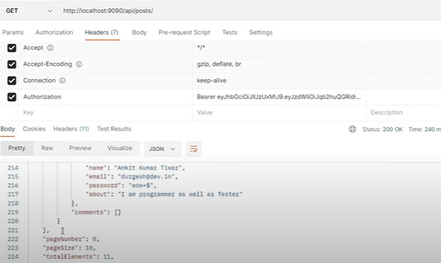

***Swagger Api Documentation***

